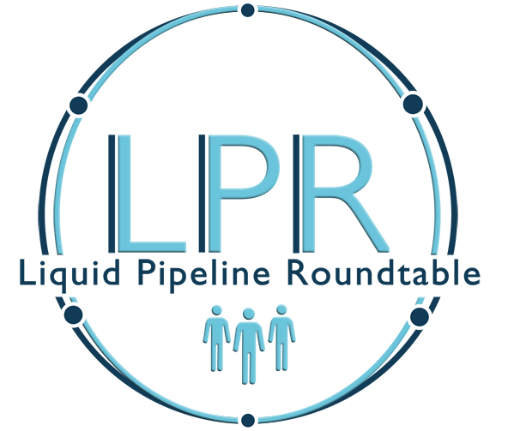

The Liquid Pipeline Roundtable (LPR) is a member group of Human Resources professionals representing companies who operate pipeline systems that transport crude oil.
The purpose of the Roundtable is to enhance professionalism and increase the effectiveness of the Human Resources departments within the liquid pipeline industry by:
- Promoting Human Resources skills and competency
- Providing for exchange of ideas and discussion by member companies
- Providing pertinent information to member companies related to Human Resources management
The member companies represented in this group are diverse in their size and organization structure and range from independent pipeline companies to fully diversified major petroleum companies. The primary function of this group is to conduct an annual industry specific compensation survey for the membership and provide an avenue for member companies to conduct informal pulse surveys throughout the year.

A multi-day annual conference/business meeting of the LPR is scheduled each fall (last week of September or one of the first two weeks of October) for review of the compensation survey results, networking, subcommittee reports, guest speaker presentations, and roundtable discussion of benchmarking questions or other topics submitted by the membership. Attendance at this fall meeting is typically by senior Compensation/Benefit staff and Human Resource management professionals.

The LPR has a Steering Committee elected by the membership or appointed as governed by a set of by-laws approved by the membership. The Steering Committee has a Compensation Subcommittee (Comp Committee) made up of LPR members who wish to volunteer their time to assist with the design (initiate/approve survey changes) and implementation of the annual compensation survey through an independent third-party administrator. This Committee provides additional networking opportunities and may periodically arrange meetings to provide training necessary to complete the survey and develop reports online. The Comp Committee is chaired by a Steering Committee member and typically has 6-10 general LPR members assisting.
All in-person and virtual meetings of the LPR are hosted by member companies. The costs of the in-person meetings (meeting space, food, conference materials/events, etc.) is shared equally by each attendee. Historically, there have been 40+ member companies at any one time in the LPR.

